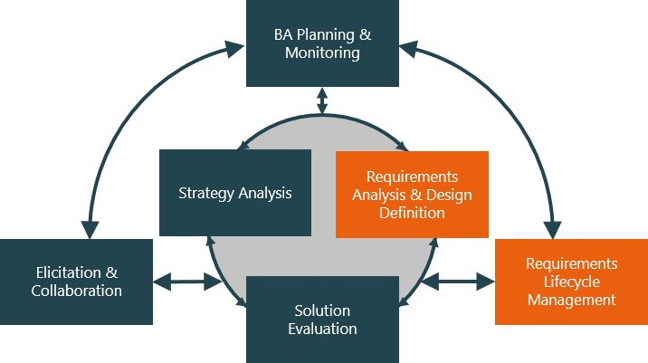

**Evaluate and communicate business requirements**

18156 Hoang Ngan Vu

|  |  |  |  |
| --- | --- | --- | --- |
| Name of Student | Hoang Ngan Vu | ID | 18156 |

# Assessment –

# Research & Questioning

Contents

Assessment – 1

Research & Questioning 1

***Instructions:*** 1

***Business Scenario*** 1

***Task 1: Determine support areas*** 2

***Task 2: Identify stakeholders*** 3

***Task 3: Develop support procedures*** 4

***Task 4: Assign Support Personnel*** 6

***Task 5: Short Answer Questions*** 6

***Task 6: Multiple Choice Questions*** 7

Index 12

#### View My Web Support:

https://nganvu197.github.io/projectnganvu/

#### *Instructions:*

This assessment is to be completed individually. In this assessment you will be working through a number of written tasks based on case scenarios or research that relate directly to each element of competency for this cluster. Outlined below is information on how each of the tasks relates the element of competency covered.

Learn how to make Google Form: <https://www.youtube.com/watch?v=BtoOHhA3aPQ&t=4s>

Your tasks:

#### *Business Scenario*

D&K Books Pty Ltd is a bookstore owned by Mr. Dean Kerr. The business occupies two levels of an office building connected by escalators and lifts. D&K Books employs approximately six sales staff, one operation manager, two administrative officers, a bookkeeper and a marketing manager. They have an Ethernet network consisting of ten PCs (Intel I3 Desktop cloned), two switches, a router and three printers. They use the QuickBooks software to manage their entire business, including sales, inventory, ordering, accounts receivable, accounts payable, payroll and employee management. They also have two EFTPOS terminals one on each floor.

D&K Books has a Linux server that stores all of the data including the QuickBooks database. The server is backed up to tape regularly. They also have a website (hosted on an Australian ISP’s server, dynamic and static pages using asp.net) on which customers can browse the product catalogue and view current specials. They also lease a telephone system from Live Telecoms. The PABX (phone system) consists of a main switchboard and five remote phones with three incoming lines and a message-on-hold queue system.

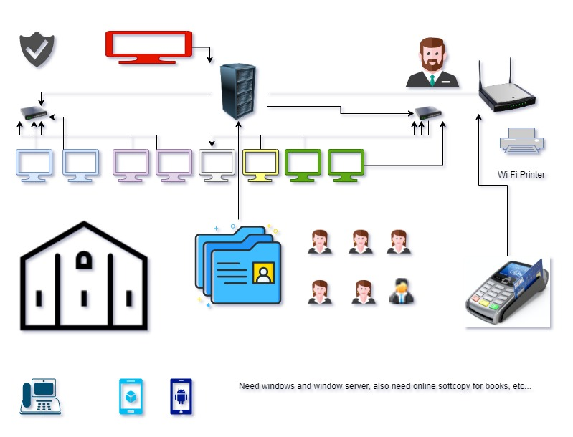

Good network system, you need setup at least:

|  |  |
| --- | --- |
| Hard ware | Software |
| Server X 1 | Window Server |
| Computer X 8 | Windows |
| Printer X 1 | SQL server |
| Telephone X 8 | Virus Protection |
| Modern X 2 | MS office |
| Network Cable | EFTPOS machine |

#### *http://imapwebsolutions.com/wp-content/uploads/2014/07/linux-dedicated-server.pngTask 1: Determine support areas*

Identify information technology (HW and SW) and list the technology in use in D&K Books and consider the following:

* What sort of support does the technology require?
* Who is likely to provide this support?
* Does the support arrangement already exist?

Present your answer in a table such as the one below:

|  |  |  |  |  |
| --- | --- | --- | --- | --- |
| **Technology** | **Description** | **Support Required** | **Provider** | **Support Already exists? (Yes/No)** |
| QuickBooks Software | Software that manages sales, inventory, ordering, accounts receivable, accounts payable, payroll and employee management | Customisation, training, upgrades, bug fixes (patching), user support, maintenance | [www.intuit.com.au](http://www.intuit.com.au)  online to find more | No |
| PC’s | Intel I3 Desktop Cloned | Upgrades, repairs, troubleshooting, maintenance, backup, customisation, protect and secure | Intel | No. A technician will be needed for this job |
| Server  IconExperience » V-Collection » Server Icon | Linux Server with tape backup.  May need upgrade to hard disk backup | User account management, security policy implementation, home folder management, permissions management, backup and restore, operating system patching, software installation |  | No |
| EFTPOS | Payment portal | Security measure, banking and card industry compliance | Bank | Yes |
| Telephone system | Live Telecoms. The PABX (phone system) consists of a main switchboard and five remote phones with three incoming lines and a message-on-hold queue system. | Phone company, stable connection, telecom equipment | Telstra, Vodafone, Optus, etc.  Zoom phone immigration | Yes |
| Website | Hosted on an Australian ISP’s server, dynamic and static pages using asp.net | Security and privacy policy, data storage and backup | Godaddy  Squarespace  Wix | Yes |
| Network | Wireless | Security and privacy policy | No | No |

Please review my website: <https://nganvu197.github.io/projectnganvu/#businesscase>

#### *Task 2: Identify stakeholders*

Identify stakeholders related in D&K Books system

All the staff members are stakeholders:

* Business owners
* Line managers and supervisors
* On-site workers
* Remote workers

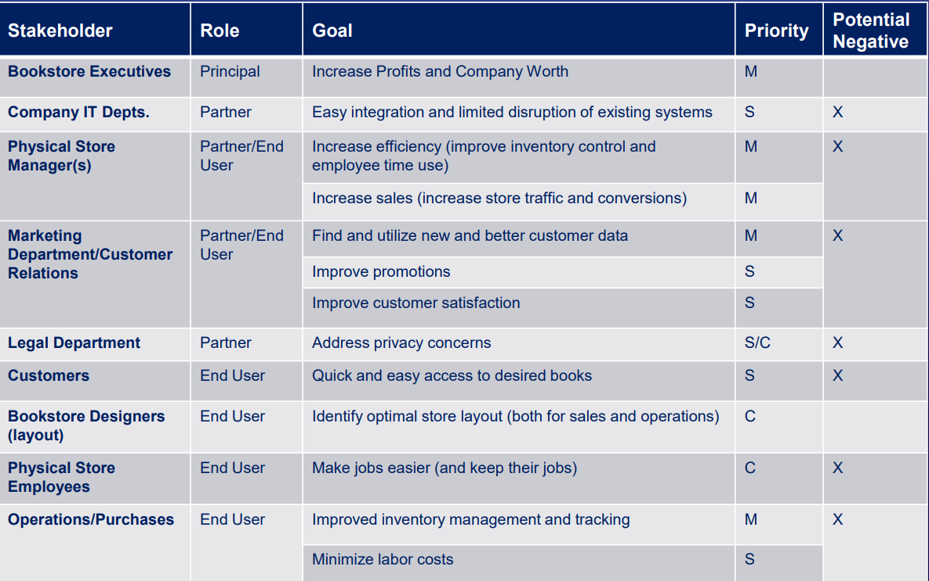

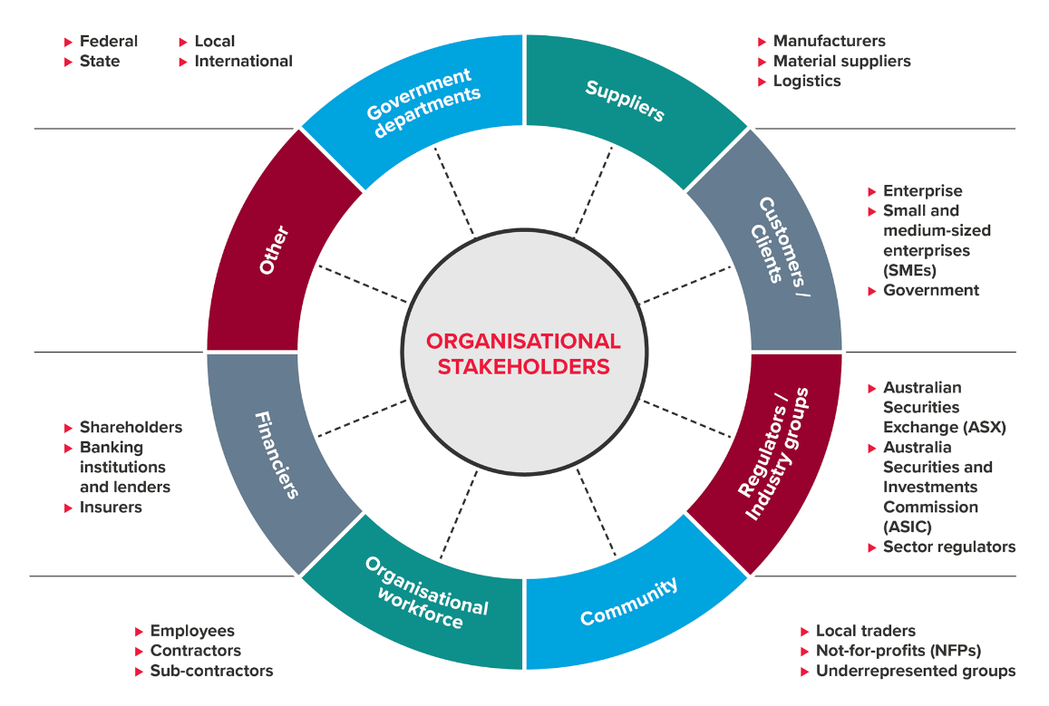

Your comment: Stakeholders can be broken down into two groups, classed as internal and external. Each has their own set of priorities and requirements from the business.

* Internal: Employees, Shareholders, Managers, The Board of Directors
* External: Customers, Suppliers, Government and Regulatory Bodies, Communities

#### *Task 3: Develop support procedures*

1. Describe one positive and one negative experience you have had when seeking assistance from a telecommunication company, an ISP or a computer supplier. Your experience may be via telephone, email or even voice recognition.

|  |  |  |
| --- | --- | --- |
| Type | Positive | Negative |
| Telephone | Direct and immediate assistance | No written forms if needed |
| Email | Written responses with visible attachments | Longer wait time |
| Face to face | Prioritised to get help | Time and money consuming |
| Chatbots (on company website, app, etc.) | Quick responses | Short messages unable to contain much information |

1. Using the experiences described above please answer the following questions.
   1. What support aspects were professional and/or unprofessional?
   2. How long did the support process take?
   3. Were the steps logical?
   4. Did they solve your problem?
   5. Was the call deflected to another area?



|  |  |  |
| --- | --- | --- |
| Items | Professional | Unprofessional |
| What support aspects | Helpful, informative, friendly, patient | Impatient, unknowledgeable, too casual |
| How long | As quick as possible depending on the types of inquiries | Longer wait time even with simple questions |
| Steps logical | Yes, follow procedures or common sense | No, the steps taken are messy and illogical |
| Solve | Problems solved | Problems unsolved |
| Another area | Take the further step to ask follow-up questions | End support once questions are answered |

Using feedback form or Google survey form is a good way to collect samples.

Here is a very simple survey demo:

The responses can be viewed as a spreadsheet as well:

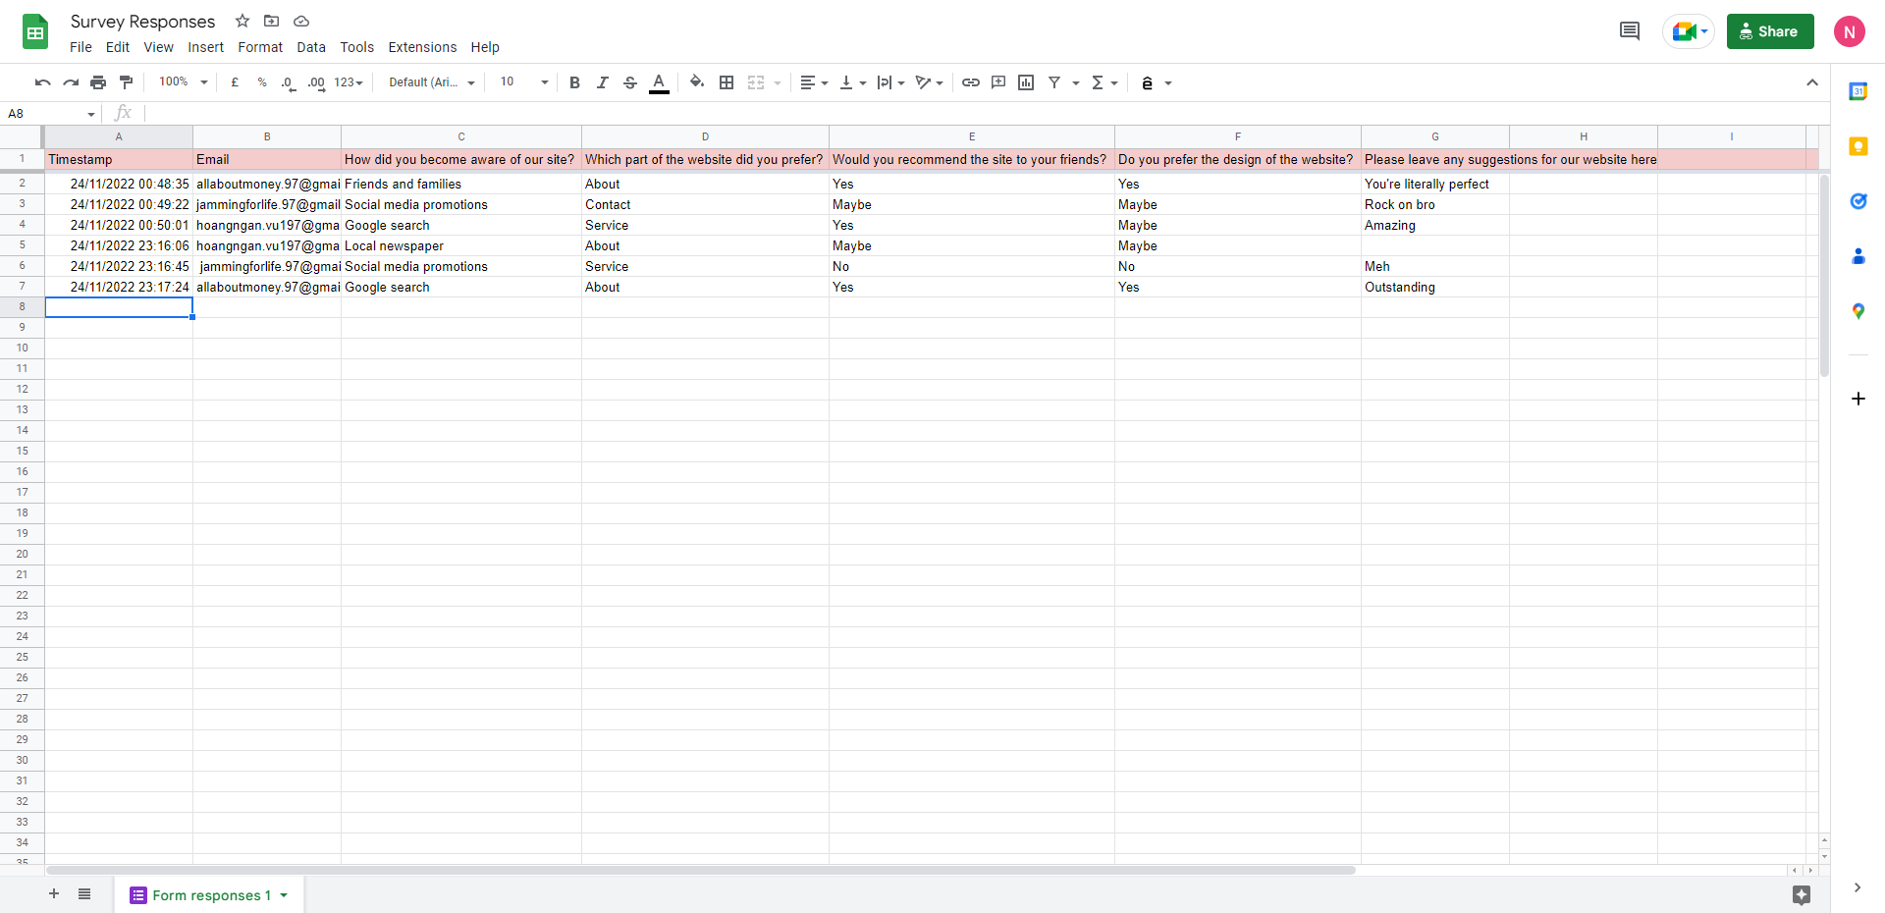

Or using the spreadsheet link:

https://docs.google.com/spreadsheets/d/11p7SbCdzZazM7Ui1KYqOr0ijPDiwFMUNaR-q9F43euA/edit?usp=sharing

Please review my website: <https://nganvu197.github.io/projectnganvu/#taskthree>

#### *Task 4: Assign Support Personnel*

Classify the following into soft skills and technical skills. Your answer should take the form of a table shown below.

|  |  |  |
| --- | --- | --- |
| **Skill** | **Soft skill** | **Technical skill** |
| A knowledge of Linux | X | X |
| The ability to work under pressure | X |  |
| The administration of Windows 2008 Server |  | X |
| The ability to formulate network and IT policies | X | X |
| The ability to write network documentation |  | X |
| The ability to give presentations | X |  |

Here is about document reequipment at support website: <https://nganvu197.github.io/projectnganvu/#structure>

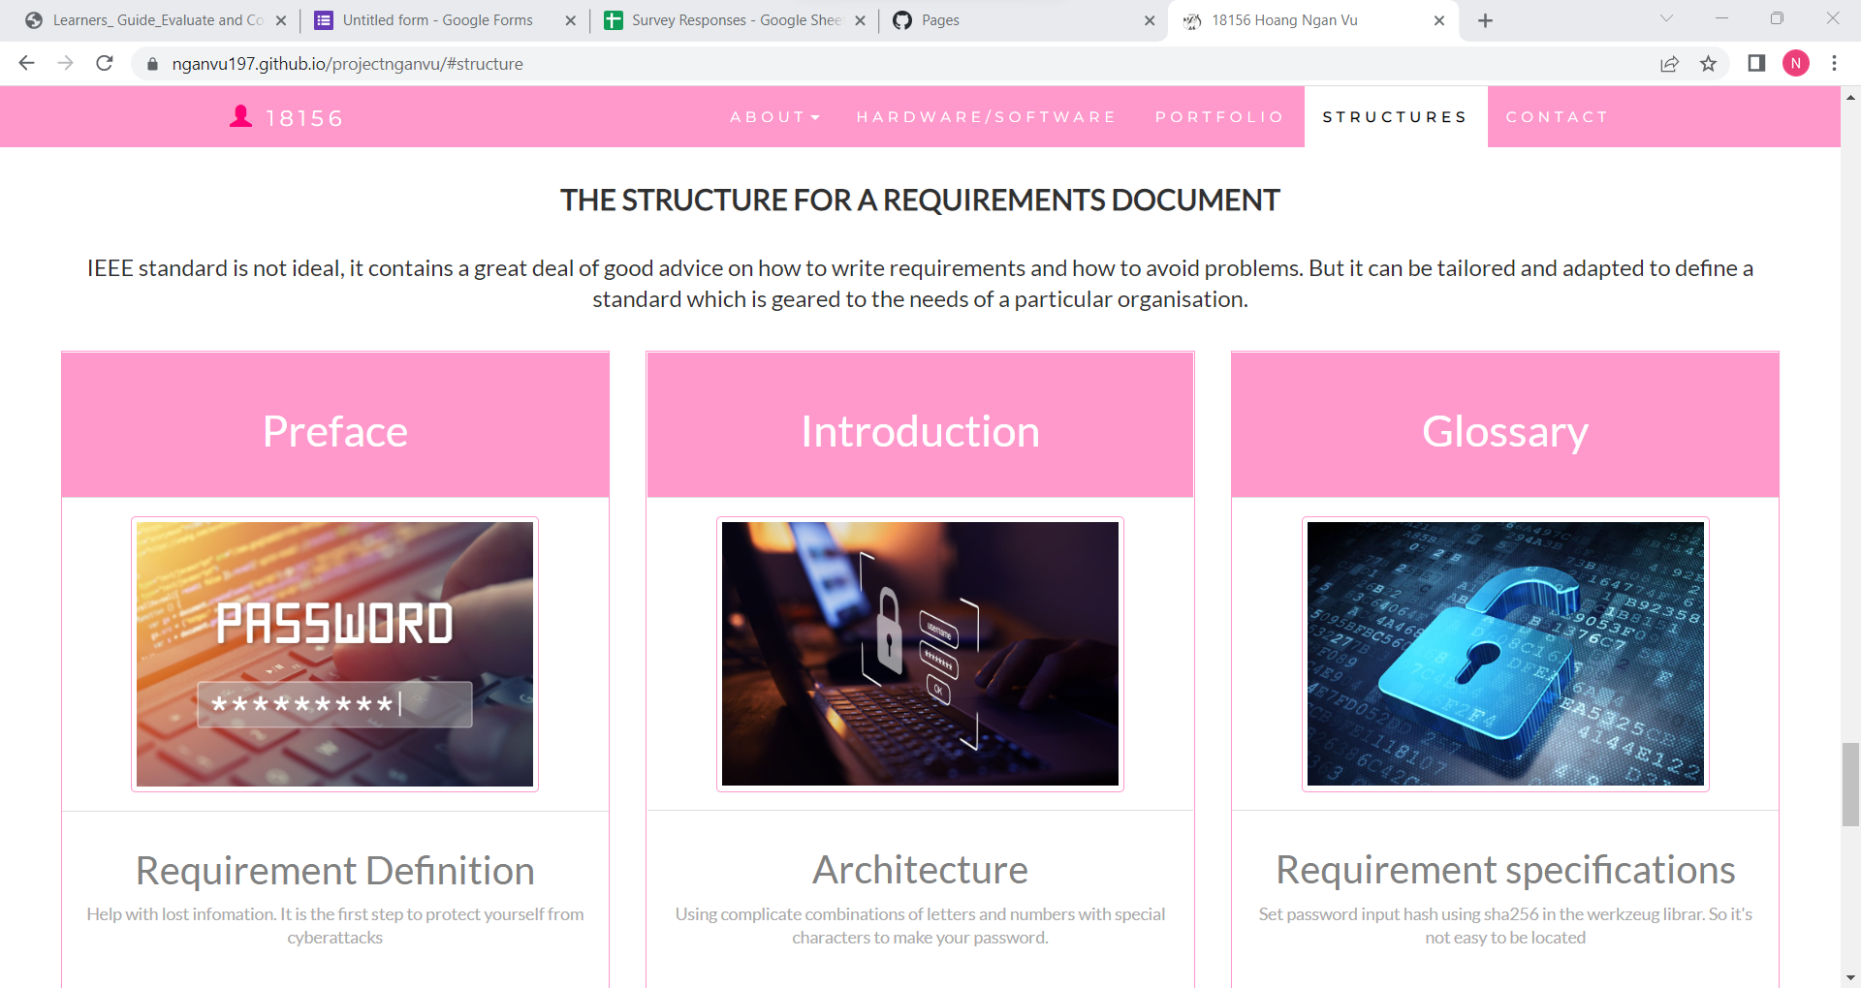

#### *Task 5: Short Answer Questions*

1. Explain the relationship between data, information and knowledge.

Data: it can be described or been given example such as symbols.

Information: data that are processed to be useful.

Knowledge: application of data and information.

Wisdom: the better understanding about thing that been created with the knowledge that we obtained.

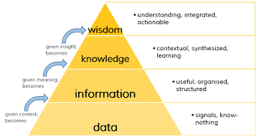

1. What is quantitative data and how can you use it.

Quantitative data are used when a researcher is trying to quantify a problem or address the "what" or "how many" aspects of a research question. It is data that can either be counted or compared on a numeric scale. For example, it could be the number of first year students at Macalester, or the ratings on a scale of 1-4 of the quality of food served at Cafe Mac. This data is usually gathered using instruments, such as a questionnaire which includes a ratings scale or a thermometer to collect weather data. Statistical analysis software, such as SPSS, is often used to analyse quantitative data.

1. What is qualitative data and how can you use it.

Qualitative data describes qualities or characteristics. It is collected using questionnaires, interviews, or observation, and frequently appears in narrative form. For example, it could be notes taken during a focus group on the quality of the food at Cafe Mac, or responses from an open-ended questionnaire. Qualitative data may be difficult to precisely measure and analyse. The data may be in the form of descriptive words that can be examined for patterns or meaning, sometimes using coding. Coding allows the researcher to categorize qualitative data to identify themes that correspond with the research questions and to perform quantitative analysis.

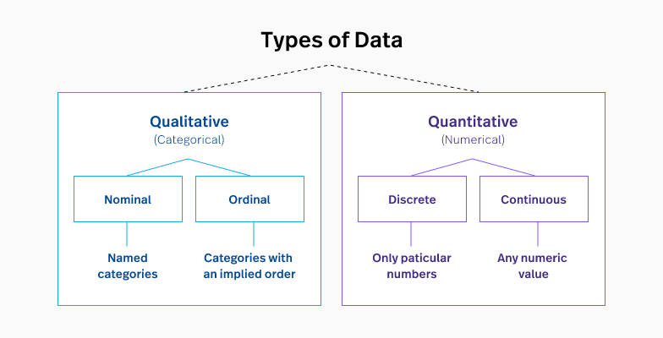

1. Give an example of how quantitative and qualitative data can be used in conjunction with each other

It may be easy to assume you need to use either qualitative or quantitative methods. In reality, they complement each other, however, resulting in deeper insights. Think of qualitative and quantitative as the “yin and yang” of research – they work fine on their own, but they deliver deeper and more useful insights when used in combination.

Employing only one type of data can harm your research project. One without the other offers an incomplete picture, lacking a strong foundation on which to base decisions. Let’s look at a few examples that illustrate the power of mixed methods:

Example 1: Google Analytics + User Interviews

Example 2: Social Media Stats + Community Engagement

Example 3: Marketing Events + Surveys

When bringing quantitative and qualitative data together, you’re closing all the gaps. A mixed-methods approach can offer a powerful path towards a deeper understanding of all aspects of your business.

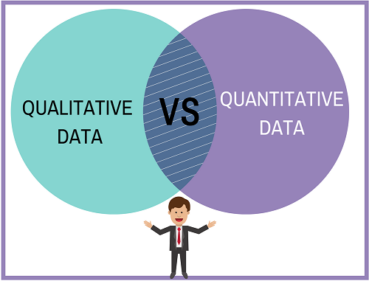

1. What sort of methods could you use to determine client requirements for a website design and key information sources?

* Survey
* Interviews
* Tests
* Physiological assessments
* Observations
* Existing record reviews
* Biological samples



1. Give some examples of client requirements for a website design

* Colour schemes, fonts and logo
* Website content requirements
* Images
* 24-hour support
* Mock-ups
* Text Content
* Access to your Domain and Hosting
* Google Drive Access
* Shortlist

I made my web support page, could be accessed by: <https://nganvu197.github.io/projectnganvu/#myPage>

#### *Task 6: Multiple Choice Questions*

1. 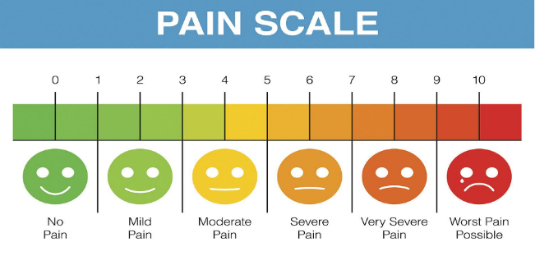Generally, how many points should a rating scale have?
   1. Five
   2. Four
   3. Ten
   4. Somewhere from 4 to 11 points Reason

Web refers: <https://lumoa.me/blog/rating-scale>

A rating scale is a closed-end survey question that is used to evaluate how survey responders feel about a particular product or statement.

Comment: I like 10 points. It is easy and clear to get the best feedback way.

1. What is the problem(s) with this set of response categories to the question “What is your current age?”

* 1-5
* 5-10
* 10-20
* 20-30
* 30-40
  1. The categories are not mutually exclusive
  2. The categories are not exhaustive
  3. Both a and b are problems Reason
  4. There is no problem with the above set of response categories

Reference: <https://www.cvent.com/en/blog/events/survey-response-design-mutually-exclusive-collectively-exhaustive-categories>

First, the categories (response options) must be mutually exclusive, which means they do not overlap with one another. Second, survey response options must be collectively exhaustive, meaning they provide all possible options that could comprise a response list.

Comment: The options should be as following:

* <10
* 11 – 25
* 26 – 45
* 46 – 65
* >65



1. You should mix methods in a way that provides complementary strengths and no overlapping weaknesses. This is known as the fundamental principle of mixed research.
   1. True Reason
   2. False

Reference: <https://voccii.com/qualitative-and-quantitative-data>

Think of qualitative and quantitative as the “yin and yang” of research – they work fine on their own, but they deliver deeper and more useful insights when used in combination.

Comment: Quantitative provides the what and qualitative provides the why, hence they need to be used wisely in collaboration

1. According to the text, questionnaires can address events and characteristics taking place when?
   1. In the past (retrospective questions)
   2. In the present (current time questions)
   3. In the future (prospective questions)
   4. All of the above Reason

Reference: <https://learning.closer.ac.uk/learning-modules/introduction/types-of-longitudinal-research/prospective-vs-retrospective-studies/>

In prospective studies, individuals are followed over time and data about them is collected as their characteristics or circumstances change. In retrospective studies, individuals are sampled, and information is collected about their past.

1. Which of the following are principles of questionnaire construction?
   1. Consider using multiple methods when measuring abstract constructs
   2. Use multiple items to measure abstract constructs
   3. Avoid double-barrelled questions
   4. All of the above
   5. Only b and c Reason

Reference: <http://www.analytictech.com/mb313/principl.htm>

Avoid double-barrelled questions and vagueness. Avoid false premises and negatives.

1. Which of these is not a method of data collection?
   1. Questionnaires
   2. Interviews
   3. Experiments Reason
   4. Observations

Reference: <https://humansofdata.atlan.com/2017/08/4-data-collection-techniques-ones-right/>

The 4 data collection techniques are: Observation, Questionnaires, Interviews, Focus group

Comment: Experiment is not a method of data collection. Experiment is a procedure which can be repeated for indefinite times. It is also known as trial.

1. Secondary/existing data may include which of the following?
   1. Official documents
   2. Personal documents
   3. Archived research data
   4. All of the above Reason

Reference: <https://www.albert.io/blog/data-collection-methods-statistics/#:~:text=do%20not%20exist.-,Experiments,their%20effect%20on%20other%20variables>.

When you collect data after another researcher or agency that initially gathered it makes it available, you are gathering secondary data. Examples of secondary data are census data published by the US Census Bureau, stock prices data published by CNN and salaries data published by the Bureau of Labor Statistics.

1. An item that directs participants to different follow-up questions depending on their response is called a ____________.
   1. Response set
   2. Probe
   3. Semantic differential
   4. Contingency question Reason

Reference: <https://skeepers.io/en/blog/customer-surveys-what-are-filter-questions-is-there-an-alternative/>

As the name suggests, a filter question is a question that aims to filter survey respondents. This age-old process is also used to target survey and customer/marketing study respondents.

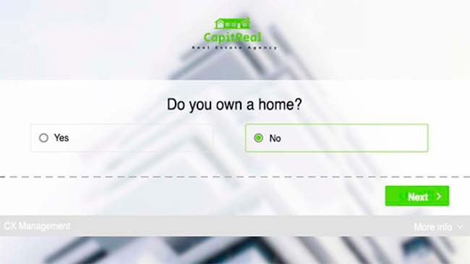

1. Which of the following terms best describes data that were originally collected at an earlier time by a different person for a different purpose?
   1. Primary data
   2. Secondary data Reason
   3. Experimental data
   4. Field notes

Reference: <https://www.albert.io/blog/data-collection-methods-statistics/#:~:text=do%20not%20exist.-,Experiments,their%20effect%20on%20other%20variables>.

When you collect data after another researcher or agency that initially gathered it makes it available, you are gathering secondary data. Examples of secondary data are census data published by the US Census Bureau, stock prices data published by CNN and salaries data published by the Bureau of Labor Statistics.

1. Researchers use both open-ended and closed-ended questions to collect data. Which of the following statements is true?
   1. Open-ended questions directly provide quantitative data based on the researcher’s predetermined response categories
   2. Closed-ended questions provide quantitative data in the participant’s own words
   3. Open-ended questions provide qualitative data in the participant’s own words Reason
   4. Closed-ended questions directly provide qualitative data in the participants’ own words

Reference: <https://www.surveymonkey.com/mp/comparing-closed-ended-and-open-ended-questions/>

Open-ended questions are exploratory in nature, and offer the researchers rich, qualitative data. In essence, they provide the researcher with an opportunity to gain insight on all the opinions on a topic they are not familiar with.

1. Open-ended questions provide primarily ______ data.
   1. Confirmatory data
   2. Qualitative data Reason
   3. Predictive data
   4. None of the above

Reference: <https://www.surveymonkey.com/mp/comparing-closed-ended-and-open-ended-questions/>

Open-ended questions are exploratory in nature, and offer the researchers rich, qualitative data. In essence, they provide the researcher with an opportunity to gain insight on all the opinions on a topic they are not familiar with.

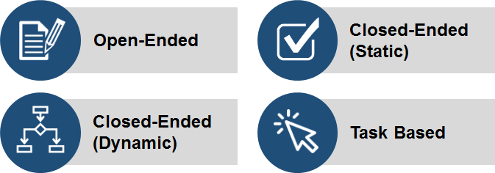

1. Which of the following is true concerning observation?
   1. It takes less time than self-report approaches
   2. It costs less money than self-report approaches
   3. It is often not possible to determine exactly why the people behave as they do Reason
   4. All of the above

Reference: <https://www.cdc.gov/healthyyouth/evaluation/pdf/brief16.pdf>

Observation is way of gathering data by watching behaviour, events, or noting physical characteristics

in their natural setting. However, it does not increase your understanding of why people

behave as they do.

Comment: Observation can be a difficult method to implement since it can be affected by the observers’ bias and people behave more naturally when they’re not being watched.

1. Qualitative observation is usually done for exploratory purposes; it is also called ___________ observation.
   1. Structured
   2. Naturalistic Reason
   3. Complete
   4. Probed

Reference: <https://delvetool.com/blog/qualobservation>

Qualitative observation enables the researcher to observe, interact and gain a rich picture of participants in their natural environment. This data collection method allows you to better understand the processes, culture, or people under study. Qualitative observations are usually used by social scientists, sociologists, and psychologists to gain a more comprehensive understanding of human and animal behaviour.

1. When constructing a questionnaire, it is important to do each of the following except ______.
   1. Use "leading" or "loaded" questions Reason
   2. Use natural language
   3. Understand your research participants
   4. Pilot your test questionnaire

Reference: <https://www.formassembly.com/blog/leading-loaded-questions/>

If you’re not aware of your own preconceived notions as you create web forms and customer surveys, leading and loaded questions could influence your users into filling out answers that don’t accurately reflect their own beliefs. Tainted, half-true data isn’t helpful for you or the people you’re sharing it with.

1. Another name for a Likert Scale is a(n):
   1. Interview protocol
   2. Event sampling
   3. Summated rating scale Reason
   4. Ranking

Reference: <https://conjointly.com/kb/likert-scaling/>

When respondents use the scale of 1 to 5 or 1 to 7, the final score for the respondent on the scale is the sum of their ratings for all of the items (this is why this is sometimes called a “summated” scale).

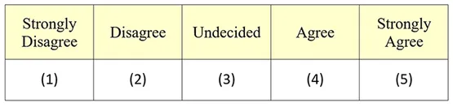

1. Which of the following is not one of the six major methods of data collection that are used by educational researchers?
   1. Observation
   2. Interviews
   3. Questionnaires
   4. Checklists Reason

Reference: <https://www.jotform.com/data-collection-methods/>

Here are the top six data collection methods:

* Interviews
* Questionnaires and surveys
* Observations
* Documents and records
* Focus groups
* Oral histories

1. The type of interview in which the specific topics are decided in advance but the sequence and wording can be modified during the interview is called:
   1. The interview guide approach Reason
   2. The informal conversational interview
   3. A closed quantitative interview
   4. The standardized open-ended interview

Reference: <https://uta.pressbooks.pub/foundationsofsocialworkresearch/chapter/9-2-qualitative-interviews/>

In a qualitative interview, the researcher usually develops an interview guide in advance to refer to during the interview (or memorizes in advance of the interview). An interview guide is a list of questions or topics that the interviewer hopes to cover during the course of an interview. It is called a guide because it is simply that—it is used to guide the interviewer, but it is not set in stone.

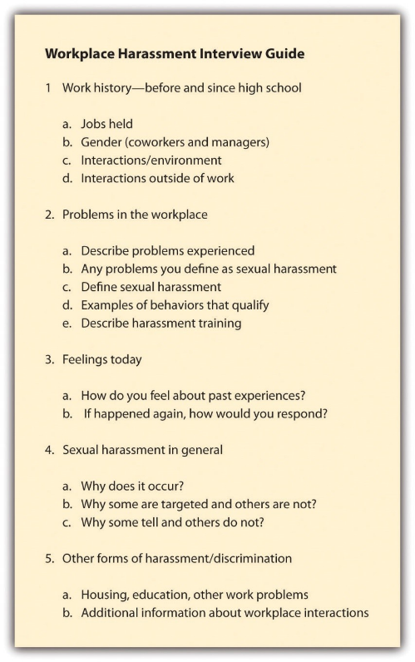

1. Which one of the following in not a major method of data collection:
   1. Questionnaires
   2. Interviews Reason
   3. Secondary data
   4. Focus groups
   5. All of the above are methods of data collection

Reference: <https://www.sociologygroup.com/advantages-disadvantages-interview-research/>

Conducting interview studies can be very costly as well as very time-consuming.

An interview can cause biases. For example, the respondent’s answers can be affected by his reaction to the interviewer’s race, class, age or physical appearance.

Interview studies provide less anonymity, which is a big concern for many respondents.

There is a lack of accessibility to respondents

Comment: I believe the answer should be e) All of the above since interviews are considered a very common way to collect data

1. A question during an interview such as “Why do you feel that way?” is known as a:
   1. Probe Reason
   2. Filter question
   3. Response
   4. Pilot

Reference: <https://blog.readytomanage.com/examples-of-probing-interview-questions/>

Probing is asking follow-up questions when we do not fully understand a response, when answers are vague or ambiguous or when we want to obtain more specific or in-depth information.

Comment: Other examples of probing questions are:

“Tell me more about that.”

“Why did you do that?”

“What did you learn?”

1. A census taker often collects data through which of the following?
   1. Standardized tests
   2. Interviews
   3. Secondary data
   4. Observations Reason

Reference: <https://www.socialsciencespace.com/2020/01/what-is-census-data/>

Census data is captured from households, institutions, and businesses through paper and online forms and, when necessary, through on-site visits and canvassing.

Comment: I think b) Interviews is also a right answer since many believe Interviews would be normally used for census purposes.

1. The researcher has secretly placed him or herself (as a member) in the group that is being studied. This researcher may be which of the following?
   1. A complete participant Reason
   2. An observer-as-participant
   3. A participant-as-observer
   4. None of the above

Reference: <https://measuringu.com/observation-role/>

This is a fully embedded researcher, almost like a spy. Here the observer fully engages with the participants and partakes in their activities.

Participants aren’t aware that observation and research is being conducted, even though they fully interact with the researcher. This has sometimes been referred to as “going native,” in reference to performing indigenous fieldwork.

Comment: In the service and retail industry, the mystery shopper acts as a complete participant, as they come in like a normal customer to observe and rate the location and employees.



1. Which of the following is not a major method of data collection?
   1. Questionnaires
   2. Focus groups
   3. Correlational method Reason
   4. Secondary data

Reference: <https://www.jotform.com/data-collection-methods/>

Here are the top six data collection methods:

* Interviews
* Questionnaires and surveys
* Observations
* Documents and records
* Focus groups
* Oral histories

1. Which type of interview allows the questions to emerge from the immediate context or course of things?
   1. Interview guide approach
   2. Informal conversational interview Reason
   3. Closed quantitative interview
   4. Standardized open-ended interview

Reference: <https://ag.arizona.edu/sfcs/cyfernet/cyfar/Intervu5.htm#:~:text=1)%20Informal%20Conversational%20Interview%3A%20This,the%20topics%20are%20not%20predetermined>.

Conversational Interview: This type of interview may occur spontaneously in the course of field work, and the respondent may not know that an "interview" is taking place. Questions emerge from the immediate context, so the wording of questions and even the topics are not predetermined.

1. When conducting an interview, asking "Anything else?, What do you mean?, Why do you feel that way?," etc, are all forms of:
   1. Contingency questions
   2. Probes Reason
   3. Protocols
   4. Response categories

Reference: <https://blog.readytomanage.com/examples-of-probing-interview-questions/>

Probing is asking follow-up questions when we do not fully understand a response, when answers are vague or ambiguous or when we want to obtain more specific or in-depth information.

Comment: Other examples of probing questions are:

“Tell me more about that.”

“Why did you do that?”

“What did you learn?”

1. When constructing a questionnaire, there are 15 principles to which you should adhere. Which of the following is not one of those principles?
   1. Do not use "leading" or "loaded" questions
   2. Avoid double-barrelled questions
   3. Avoid double negatives
   4. Avoid using multiple items to measure a single construct Reason

Reference: <https://measuringu.com/single-multi-items/>

Using only a single item to measure a construct is often greeted with scepticism—the Net Promoter Score being a recent example. It’s based on responses to only a single item (how likely are you to recommend to a friend) to measure loyalty.

1. A customer-based Service Level Agreement structure includes:
   1. An SLA covering all Customer groups and all the services they use
   2. SLAs for each service that are Customer-focused and written in business language
   3. An SLA for each service type, covering all those Customer groups that use that Service
   4. An SLA with each individual Customer group, covering all of the services they use Reason

Reference: <https://blog.masterofproject.com/3-types-sla/>

A customer-based SLA is a contract with one customer, covering all the services used by this customer.

Comment: If the IT service provider provides several services for the business and the customers, and if all the service levels are documented in one customer service level agreement for the provided services, it will be a customer-based SLA.

1. Which of the following best describes the goal of Service Level Management?
   1. To maintain and improve IT service quality in line with business requirements Reason
   2. To provide IT services at the lowest possible cost by agreeing with Customers their minimum requirements for service availability and ensuring performance does not exceed these targets
   3. To provide the highest possible level of service to Customers and continuously improve on this through ensuring all services operate at maximum availability
   4. To ensure that IT delivers the same standard of service at the least cost

Reference: <https://www.invensislearning.com/blog/service-level-management/>

The main purpose of service level management is to make sure that every IT service presently being provided and planned for the future is delivered as per the previously agreed upon service level targets.

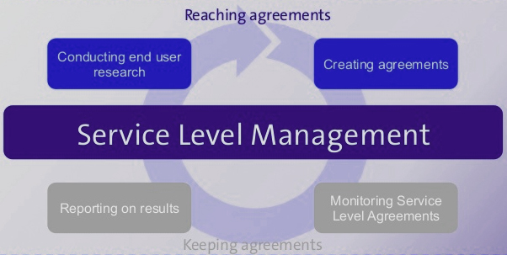

1. The process to implement SLAs comprises of the following activities in sequence:
   1. Draft SLAs, catalogue services, review underpinning contracts and OLAs, draft SLRs, negotiate, agree SLAs
   2. Draft SLAs, review underpinning contracts and OLAs, negotiate, catalogue services,
   3. Review underpinning contracts and OLAs, draft SLAs, catalogue services, negotiate, agree SLAs
   4. Catalogue services, establish SLRs, review underpinning contracts and OLAs, negotiate service levels, agree SLAs Reason

Reference: <https://www.ibm.com/docs/en/wsr-and-r/8.0?topic=profile-service-level-agreement-lifecycle>

You use the service level agreement (SLA) lifecycle to govern a service level agreement from being initially identified, through to being activated, and, eventually, terminated when it is no longer required.

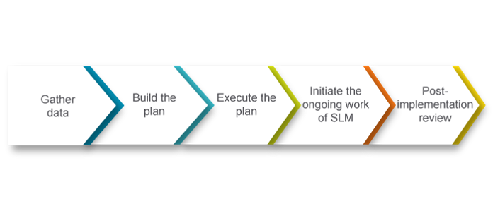

1. Which of the following is an example of a service level agreement (SLA) between information systems support unit and a research unit in the laboratories of a large company?
   1. The maximum response time to get the system operational should it fail.
   2. The minimum ‘up-time’.
   3. The types of information that will be provided as standard.
   4. All of the above. Reason

Reference: <https://www.upcounsel.com/service-level-agreements-between-departments>

Service level agreements between IT and other departments can act as an incentive for greater understanding of roles, promoting greater cooperation that results in better system performance.

1. Some organisations bring a degree of formality to the internal customer concept by encouraging (or requiring) different parts of the operation to agree on:
   1. Internal service agreements
   2. Service level agreements Reason
   3. Formal provision agreements
   4. Delivery agreements

Reference: <https://www.cio.com/article/274740/outsourcing-sla-definitions-and-solutions.html>

A service-level agreement (SLA) defines the level of service expected by a customer from a supplier, laying out the metrics by which that service is measured, and the remedies or penalties, if any, should the agreed-on service levels not be achieved. Usually, SLAs are between companies and external suppliers, but they may also be between two departments within a company.

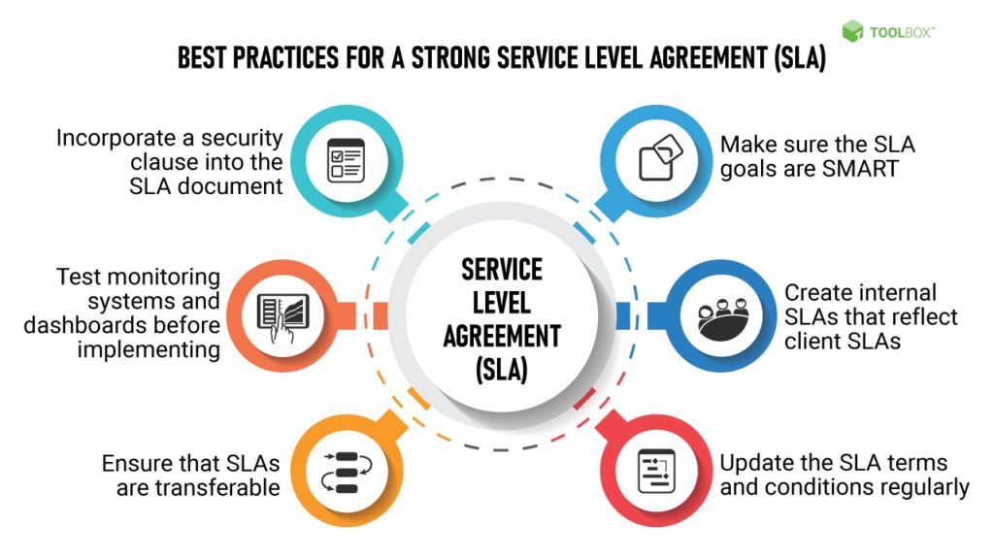

## Index

B

bookstore 3

C

categories 11

closed-ended 12

D

data collection 14

L

Linux server 3

N

negative experience 6

network 3

O

open-ended 12

observation 12

P

probe 12

S

Service Level 14

service level agreement 15

service quality 14

soft skills 9

support 6

T

technology 4

telecommunications 6